Assume node A is transmitting to node B and B is receiving from node A. Then the following statements apply (it’s all about the receiver)

1. Node A can not receive from any node while it is transmitting
2. Any node within range of node A can not receive from node A if it is not the intended recipient
3. Any node within range of A will not be able to receive from any other node while A is transmitting
4. Node B can not receive from any other node while it is receiving from node A
5. Any nodes within range of node B can not receive from node B as B is unable to send while receiving from node A
6. Any node within range of B can not send to any other node due to risk of collision with node B (receiving from node A)

Given the following:

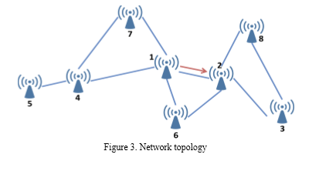

Let 1 = Node A and 2 = Node B. Going through the receivers in Node order:

|  |  |  |  |
| --- | --- | --- | --- |
| Sender | Receiver | Y/N | Reason |
| 4 | 1 | N | (i) |
| 6 | 1 | N | (i) |
| 7 | 1 | N | (i) |
| 3 | 2 | N | (iv) |
| 6 | 2 | N | (iv) |
| 8 | 2 | N | (iv) |
| 2 | 3 | N | (v) |
| 8 | 3 | N | (vi) |
| 1 | 4 | N | (ii) |
| 5 | 4 | N | (iii) |
| 7 | 4 | N | (iii) |
| 4 | 5 | Y | 5 can receive as it has no dependency on 1 or 2 |
| 1 | 6 | N | (ii) |
| 2 | 6 | N | (v) |
| 1 | 7 | N | (ii) |
| 4 | 7 | N | (iii) |
| 2 | 8 | N | (v) |
| 3 | 8 | N | (vi) |